ECEN 214

Lab 1 Report

Measurements Taken:

09/11/2019

Due: 09/18/2019

Jason Gilman

Christopher Smith

Section 508

Saad Muaddi

**Procedure**

In Lab 1, we measured various voltages across breadboard circuits. Starting with the measurement of a battery’s voltage, we used the Analog Discovery 2 device along with the waveform software to find the reading. We took two readings of the battery’s voltage, the first using only one of the channels of the AD2 device, and the other using both channels to simultaneously take the voltage reading. Next, we produced an AC voltage waveform through a circuit, and measured the voltage across our circuit as we varied the peak to peak amplitude value of our voltage source. Finally, we measured the voltage produced by a square wave source, similar to the AC voltage measurements. In the last part of the lab, a circuit containing two resistors was set up. One of the resistors resistance value was kept unknown, because the goal of this part of the lab was to use the standard voltage divider equation to obtain the resistance value of the unknown resistor. After measuring the voltage across the unknown resistor, we were able to set up the equation with the voltage of the source, the voltage across the unknown resistor, and the value of the resistor to obtain the unknown resistance value.

**Data**

Task 1: DC Voltage Measurement

|  |  |
| --- | --- |
| **Channel 1** | 1.618 VDC |
| **Channel 2** | 1.616 VDC |

Task 2: AC Voltage Measurement

|  |  |  |  |  |
| --- | --- | --- | --- | --- |
| **Frequency** | **Vpp** | **DC Offset** | **Wave Type** | **Result** |
| 3 kHz | 2 V | 0 V | Sine | RMS: 712 mVAC |
| 3 kHz | 4 V | 0 V | Sine | RMS: 1.424 mVAC |
| 3 kHz | 2 V | 0 V | Square | 986 mV |

Task 3: Measuring Resistance with a Voltmeter

|  |  |  |  |
| --- | --- | --- | --- |
| **Source Voltage (V1)** | **Known Resistor (R1)** | **Measured Voltage Across R2 (V2)** | **Result (R2)** |
| 3 VDC | 1k $Ω$ | 2.056 VDC | 2177.9661 $Ω$ |

**Calculations**

The only calculation that was needed in this lab was using the standard voltage divider equation.

$V_{2}=V_{1}R_{2}/(R_{1}+R_{2})$

We obtained the following values after measuring, detailed in the procedure section.

$R_{1}=1 kΩ$ $V_{1}=3 V$ $V_{2}=2.056 V$

Using standard algebraic practices, we obtained the following equation.

$2.056=(3R_{2})/(1000+R_{2})$ → $2.056(1000 {+R}_{2})=3R_{2}$

$2056 +2.056R_{2}=3R_{2}$ → $2056 =.944R_{2}$

$R_{2}=2177.9661 Ω$

Since the unknown resistor we chose had a 5% tolerance level, the measured value of 2177.9661 Ω was within bounds of the actual resistance value of 2200 Ω. Signatures from TA for calculations shown below:

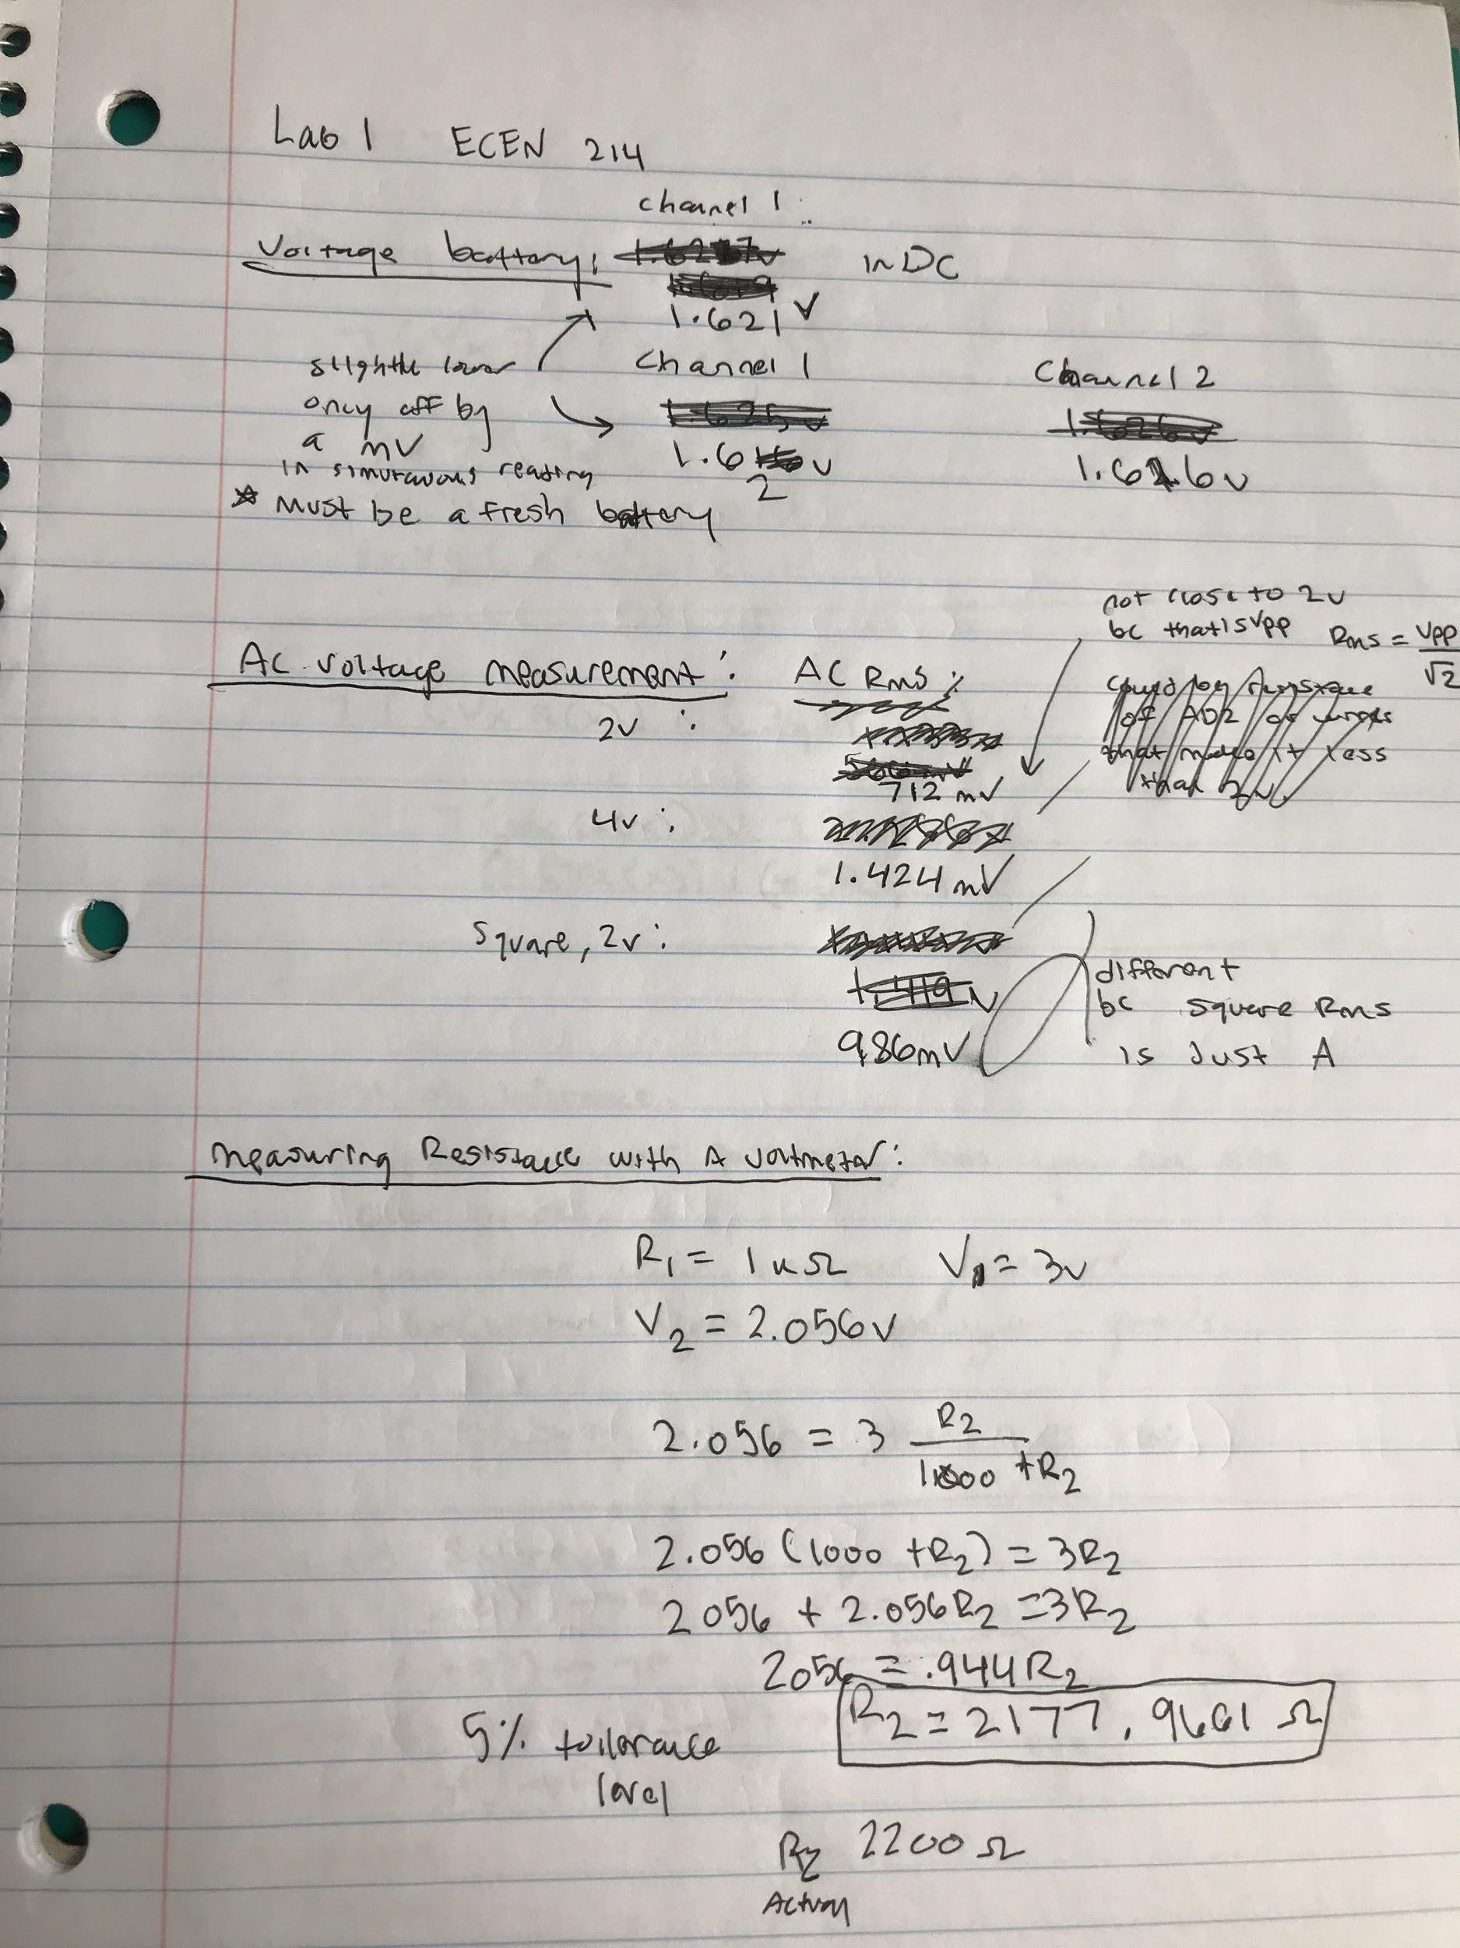

**Screen Shots from the Tasks**

Task 1: DC Voltage Measurement

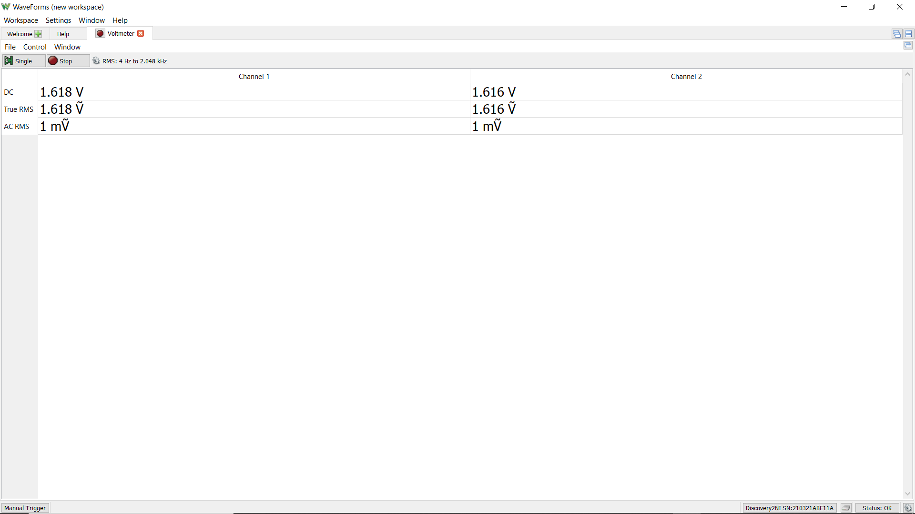

Task 2: AC Voltage Measurement

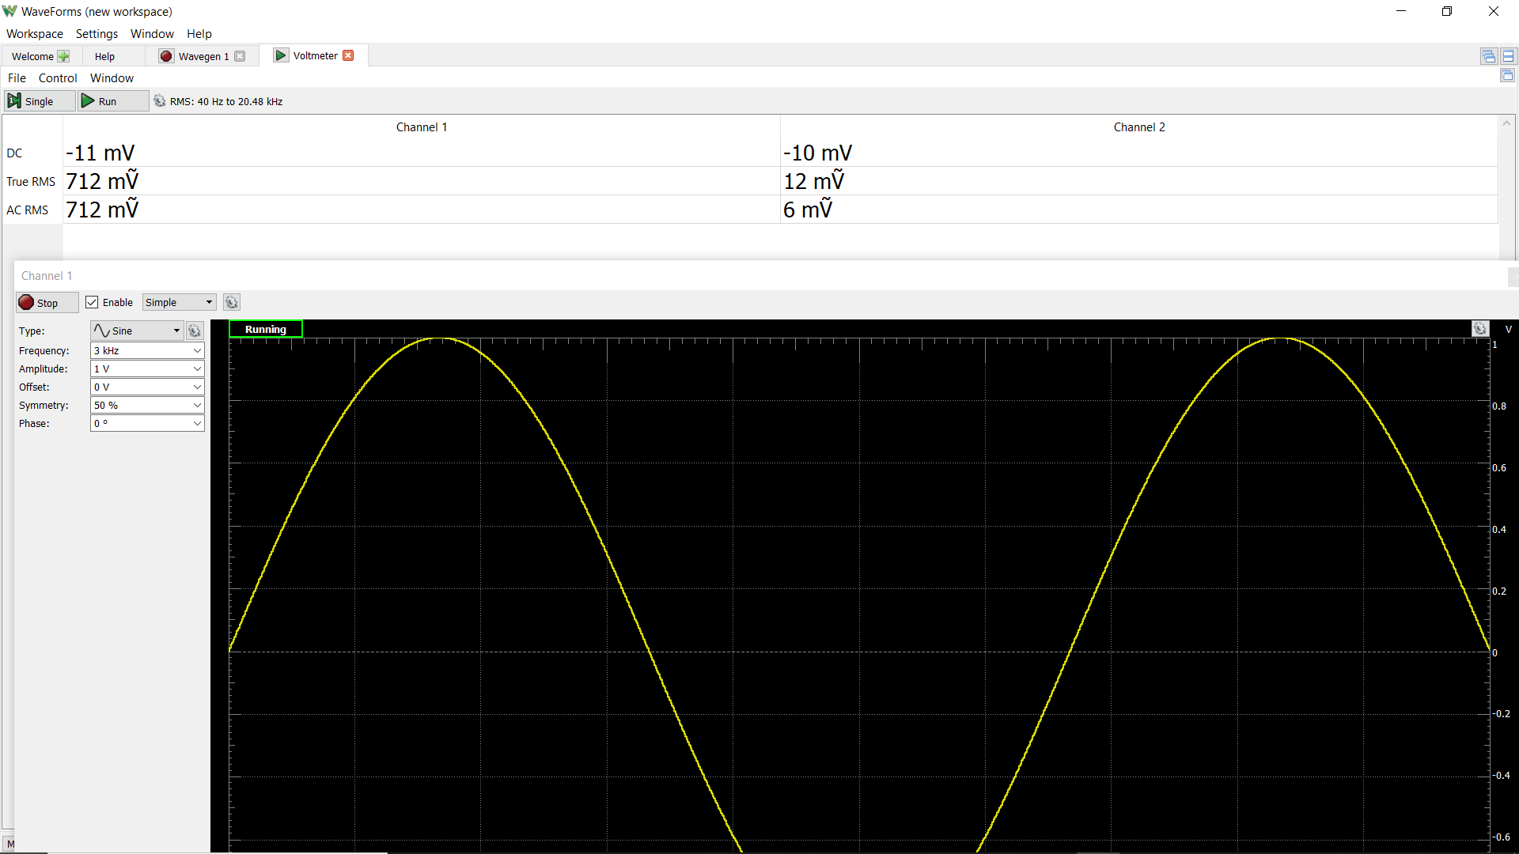



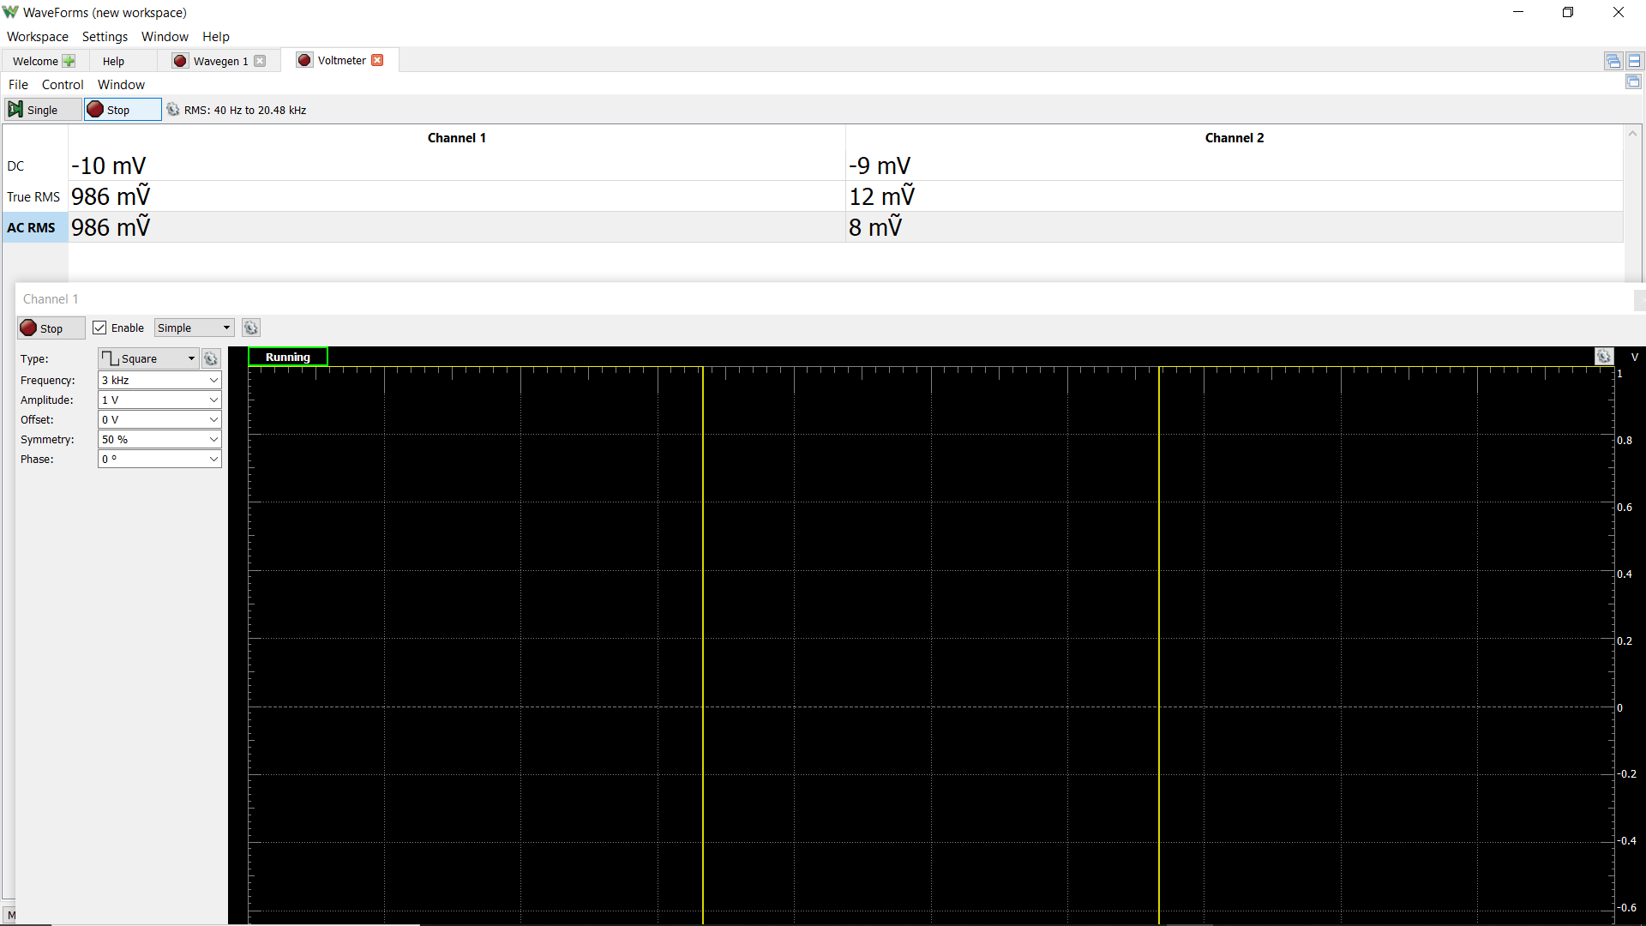

**Discussion**

In task 1, there was a difference in the reading of the battery’s voltage. When using one channel on the AD2 device to measure, the reading was slightly higher than when we used both channels simultaneously. The difference was pretty insignificant, with a difference of about a millivolt. Although, all of the voltage readings came out to be above the reported voltage reading on the battery. Each reading was around 1.6 V, while the battery was reported to be 1.5 V. This can be attributed to being a new battery that has not been drained of any charge.

In task 2, when taking the voltage reading of an AC voltage source, the reading was not close to 2 V. This was because the peak-to-peak value of the voltage source was 2 V. The Rms voltage reading is calculated as:

$V_{rms}={(V}_{pp}) / (sqrt(2))$

Meaning, the voltage reading should not be equivalent to the peak-to-peak value, because you divide by the square root of 2.

The changing of the voltage source from a sine wave to a square wave also created disparity in the measured voltage values. The equation for voltage from a square wave is calculated as:

$V_{rms}=Amplitude$

Since the source waveform changed, the equation to find the resulting voltage changes as well.

In task 3, when measuring the voltage across the unknown resistor, the reading could have been affected by any resistance of the AD2 device, or any jumper cables used. Also, the voltage produced by the AD2 device could have not been exactly the inputted value of 3 V. Both of these could have affected the calculation of the final resistance value of the unknown resistor. Although, since the unknown resistor had a tolerance level of 5%, the measured value was still within the bounds of the actual resistance value.

**Conclusion**

In conclusion, Jason and I were able to work with the Analog Discovery 2 and the Waveform software. Learning how to take measurements and implementing different types of signals using the Analog Discovery 2 will sure to be very useful not only in this class, but other classes to come. We were also able to review how to read color codes on resistors to tell how much resistance they give.

This lab was straight forward and we did not have any issues.